**Annex 1.1.**

**Fixed Service system parameters for different frequency bands**

1. **Introduction**

According to the HCM Agreement the calculation model is based on Threshold Degradation (TD); see Annex 9 of the HCM Agreement.

For the notification procedure I/N ratio is used according to the Radio Regulations.

Significant increases in data traffic have led to the requirement for by network operators for network services capable of supporting very high data rates. FS technology has that capability and is expected to play an important role to provide high quality broadband communication services high-capacity fixed wireless systems. FWS have involved over the years in future there is continuing strong evolution in terms of technologies and applications.

This Annex offers a guidance and information on the following items in relation to the future development of Fixed Service (FS):

1. **FWS use in telecommunications networks including the following**

**applications** (see Figure 1):

* Transport or trunking networks,
* Mobile backhaul networks,
* Fixed wireless access (FWA),
* Temporary networks



Figure 1. FWS use in telecommunication networks

**3. FWS band usage**

**3.1. General consideration**

Figure 2 shows the trend in the use of higher frequency bands by the FS. This indicates that studies in ITU-R on frequencies over 100 GHz will be required before 2020.

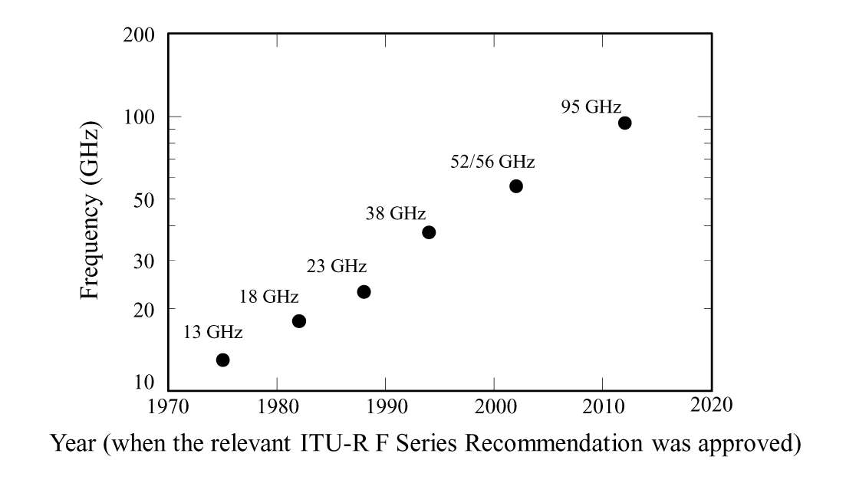

Figure2. Exploitation of higher frequency bands in FS

Figure 3 shows the trend of the bandwidth of FS, which is reflected from the approval years of ITU-R F-Series Recommendations on RF frequency arrangements.

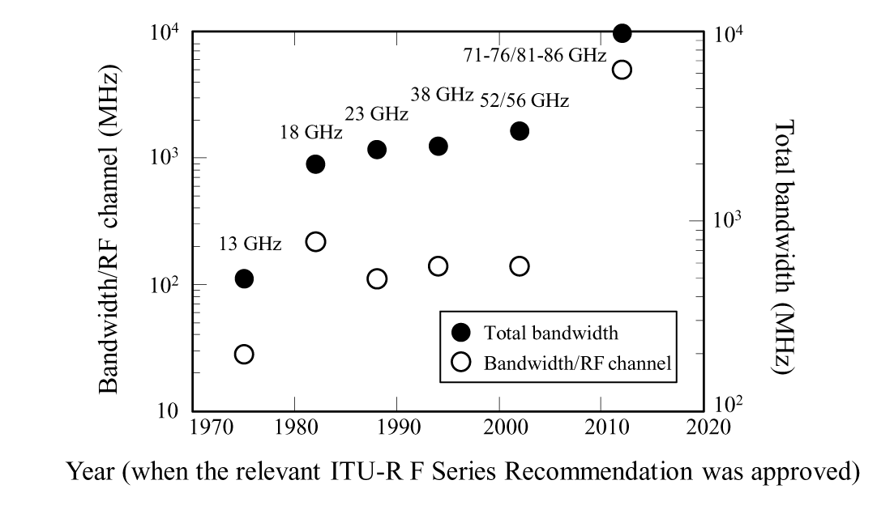

Figure 3: Bandwidth of the FS

**3.2. Spectrum use in each band.**

In order to overview the trend of FS bands in detail, Table 1 summarizes characteristics and applications of the fixed service described in the ITU-R F-Series Recommendations on RF channel arrangements above 1 GHz.

It is noted that the bandwidths of several FS band segments above 40 GHz exceed 3 GHz, and that, according to the relevant Recommendations on RF channel arrangements, the bandwidths per channel are also increasing in the higher frequency bands (e.g. in the 70 and 80 GHz band it becomes over 1 GHz).

TABLE 1

Example of characteristics and applications of frequency bands for the Fixed Service

| Band (GHz) | Typical applications | Recommendation ITU-R | Bandwidth per channel (MHz) | Typical data rates |
| --- | --- | --- | --- | --- |
| 1.35-1.53 | Transport, utilities | ITU-R F.1242 | 0.25, 0.5, 1, 2, 3.5 | 64-4000 Kbit/s |
| 3.6-4.2 | Transport | ITU-R F.635 | 30, 40, 80 | 155 Mbit/s |
| 5.925-6.425 | Transport, mobile backhaul | ITU-R F.383 | 5, 10, 20, 28, 29.65, 40, 80 | 155 Mbit/s |
| 6.425-7.125 | Transport, mobile backhaul | ITU-R F.384 | 5, 10, 20, 30, 40 | 34-311 Mbit/s |
| 7.11-7.9 | Transport, mobile backhaul | ITU-R F.385 | 3.5, 5, 7, 14, 28 | 8-155 Mbit/s |
| 10.0-10.68 | ENG | ITU-R F.747 | 1.25, 2.5, 3.5, 5, 7, 14, 28 |  |
| 10.15-10.3/ 10.5-10.65 | ENG | ITU-R F.1568 | 28, 30 |  |
| 10.7-11.7 | Transport, trunk networks, mobile backhaul, disaster recovery, ENG | ITU-R F.387 | 5, 7, 10, 14, 20, 28, 40, 60, 80 | 140 Mbit/s, 155.52 Mbit/s |
| 11.7-12.5/ 12.2-12.7 | Transport, trunk networks, ENG | ITU-R F.746 Annex 2 § 2, § 3 | 12.5, 19.18, 20, 25 | 40 Mbit/s |
| 12.75-13.25 | Transport, trunk networks, ENG | F.497 | 3.5, 7, 14, 28 | 34-140 Mbit/s |
| 14.25-14.5 |  | ITU-R F.746 Annex 3, Annex 4 | 3.5, 7, 14, 28 | 34 Mbit/s |
| 14.4-15.35 | Transport, , mobile backhaul, ENG | ITU-R F.636 | 2.5, 3.5, 5, 7, 10, 14, 20, 28, 30, 40, 50, 56 |  |
| 17.7-19.7 | Mobile backhaul, FWA | ITU-R F.595 | 1.75, 2.5, 3.5, 5, 7, 7.5, 10, 13.75, 20, 27.5, 30, 40, 50, 55, 60, 110, 220 | <10 Mbit/s, 34, 140, 280 Mbit/s |
| 21.2-23.6 | Transport, mobile backhaul, FWA | ITU-R F.637 | 2.5, 3.5, 7, 10, 14, 15, 28, 40, 50, 56, 112 | 1.5-8 Mbit/s 2-155 Mbit/s |
| 24.25-25.25/ 25.25-27.5/ 27.5-29.5 | Transport, , macro and small cell mobile backhaul, FWA | ITU-R F.748 | 3.5, 7, 14, 28, 56, 112 |  |
| 31.0-31.3 | Transport, mobile backhaul | ITU-R F.746 Annexes 5, 6 | 3.5, 7, 14, 25, 28, 50 |  |
| 31.8-33.4 | Transport, mobile backhaul, FWA | ITU-R F.1520 | 3.5, 7, 14, 28, 56, 112, 168 |  |
| 36.0-40.5 | Macro and small cell mobile backhaul, FWA | ITU-R F.749 | 2.5, 3.5, 7, 14, 28, 50, 56, 60, 112 |  |
| 40.5-43.5 | Transport, trunk networks, macro and small cell mobile backhaul, ENG, FWA | ITU-R F.2005 | 7, 14, 28, 56, 112, or variable sized blocks  (Each block size  < 1 500 MHz) |  |
| 51.4-52.6 | Transport, macro and small cell mobile backhaul, | ITU-R F.1496 | 3.5, 7, 14, 28, 56 |  |
| 55.78-57/ 57‑66 | Transport, macro and small cell mobile backhaul, | ITU-R F.1497 | 3.5, 7, 14, 28, 50, 56, 100, up to 2.5 GHz | Up to  1 Gbit/s and greater |
| 71-76 81-86 | Transport, macro and small cell mobile backhaul | ITU-R F.2006 | 125, 250, 750, 1 000, 1 250, 1 500, 1 750, 2 000, 2 250, 2 500, 2 750, 3 000, 3 250, 3 500, 3 750, 4 000, 4 250, 4 500, 5 000 |  |
| 92.0-94.0/ 94.1-95 | Transport, macro and small cell mobile backhaul | ITU-R F.2004 | 50, 100, *n* × 100 |  |

### Below 3 GHz:

FWS below 3 GHz can reach links lengths exceeding 50 km and are used in variety of applications. The available bands for these applications are very few in number and often regulated at national level; therefore, only small and medium capacity links are possible.

The recommended radio-frequency channel arrangements in these bands for FS are defined in Recommendations ITU-R F.701, ITU-R F.1098, ITU-R F.1242, ITU-R F.1243 and ITU-R F.1567.

### 3 GHz to 10 GHz

FWS from 3 GHz to 10 GHz can achieve over 50 km hop distance. Total bandwidth is sufficient for channel separations up to 28/40 MHz (or, when practical twice 28/40 MHz size); high capacity links are then possible. For such purposes, bands from 3 GHz to 10 GHz will continue to occupy an important position in the FS applications including for transport network and mobile backhaul.

The radio-frequency channel and block arrangements of these bands for FS are defined in Recommendations ITU-R F.382, ITU-R F.383, ITU-R F.384, ITU-R F.385, ITU-R F.386, ITU‑R F.635, ITU-R F.1098 and ITU-R F.1099.

### 10 GHz to 57 GHz

FWS using bands from 10 GHz to 30 GHz permit maximum link lengths ranging from about 20 km, at the lower edge of this frequency range, to about 10 km at the upper edge. Those from 30 GHz to 57 GHz can cover about a few km. The transport networks and mobile backhaul mainly use the frequency bands from 10 GHz to 38 GHz.

The radio-frequency channel and block arrangements of these bands for FS are defined in Recommendations ITU-R F.387, ITU-R F.497, ITU-R F.595, ITU-R F.636, ITU-R F.637, ITU‑R F.747, ITU-R F.748, ITU-R F.749, ITU-R F.1496, ITU-R F.1498, ITU-R F.1520, ITU‑R F.1568 and ITU-R F.2005.

### 57 GHz to 66 GHz

It should be noted that this Recommendation was developed first in 2000 for bands up to 59 GHz only. Frequency bands 59 to 64 GHz is gathering interest in particular due to a high atmospheric absorption which provides opportunity for small cell backhauling.

Also the 64-66 GHz range, where the atmospheric absorption drops down significantly, gathers interest for similar applications where longer hops are foreseen. In 2011, around 700 links were in use in this band (mainly in the 57-59 GHz range) in a few administrations. The majority of the links were used for fixed and mobile infrastructure.

The air absorption around 60 GHz (i.e. from 58 to 64 GHz) is over 10 dB/km. This condition restricts the hop length; on the other hand, the spectrum reuse efficiency is high and isolation from inter-satellite links as also very high. The spectrum reuse efficiency makes the band suitable for small cell mobile backhaul.

The radio-frequency channel and block arrangements of these bands for FS are defined in Recommendation ITU-R F.1497.

### 71 GHz to 76 GHz and 81 GHz to 86 GHz

These bands have been recently exploited for practical use. Most applications are foreseen for FWS links used for fixed and mobile infrastructure. In these bands, wide bandwidth can be used and the attenuation due to gas absorption is relatively small compared with the 60 GHz band and, in practice negligible. Therefore, this band is suitable for high-capacity transmission.

The radio-frequency channel and block arrangement of these bands for FS are defined in Recommendation ITU-R F.2006.

### 92 GHz to 95 GHz

The use of this band is just beginning. Most applications are almost the same as that with 71-76 and /81‑86 GHz bands. However, the total bandwidth of this band is 2 GHz and 0.9 GHz (92.0-94.0/94.1-95 GHz), and then the data rate of FWS in this band is smaller than that possibly provided in 71-76 and /81-86 GHz bands. The radio-frequency channel and block arrangement of these bands for FS are defined in Recommendation ITU-R F.2004.

* 1. **Digital FS system parameters**

There is a large variety of FWS in operation or being developed (planned) to meet future requirements. The system parameters can be generalized by representative systems for frequency ranges where equipment operations are consistently similar. This Annex provides details of the key radio system parameters required for interference evaluation and calculations for frequency sharing studies with other services.

**Transmitter characterization**

Equipment parameters:

The basic transmitter parameters are:

* carrier frequency
* spectral characteristics
* equivalent radiated power
* antenna radiation pattern

Operating frequencies correspond to radio-frequency channel arrangements specified in ITU-R Recommendations. The modulation type and systems capacity give a guide to the spectral characteristics of the emissions. The e.i.r.p. of the transmitter is calculated from the transmitter power, feeder losses and the antenna gain.

In cases where measured patterns are not available, the reference radiation patterns addressed in the following Recommendation should be used:

Recommendation ITU-R F.699,

Recommendation ITU-R F.1245,

Recommendation ITU-R F.1336,

**Receiver characterization**

Equipment parameters:

Assessment of the effects of interference into the FS from other services requires knowledge of the performance characteristics of the radio receiver. The following receiver parameters are important for frequency sharing studies:

* noise figure;
* noise bandwidth;
* receiver thermal noise power density;
* received signal power for 1 × 10−3, 1 × 10−6, 1 × 10−10 BER (post-error-correction);
* nominal receiver input level.

The received signal levels and interference levels could be referenced to the low noise amplifier (LNA)/mixer input of the receiver, so that they would be independent of receive antenna gain and feeder/multiplexer losses (assuming this to be the same for both transmitter/receiver).

It should also be noted that deterministic (station-by-station) sharing calculations require information on the frequency selectivity of the radio equipment. Generic sharing/compatibility studies, in the same allocated band, are usually based on co-channel interference situation; hence the noise bandwidth is sufficient.

The required signal levels for given BERs could be derived from the calculated receiver thermal noise level adding the required signal-to-thermal noise ratio, *S*/*N*,for a given BER. Information on theoretical and practical *S*/*N* for the most common modulation formats may be found in Recommendation ITU-R F.1101.

* 1. **Permitted interference**

It is necessary to specify maximum interference levels for both long- and short-term time percentages. Where aggregate long-term interference is specified, if interference from multiple sources can simultaneously occur, it should be noted that single-entry interference criteria will be correspondingly lower. In the case of short-term interference, the time percentages of interest will be related to the system performance objectives.

The long- and short-term interference levels, and associated time percentages, must be individually derived for each system type in accordance with the principles described in ITU-R Rec-F.758-5-2012, Annex 1.

* 1. **Statistic distribution over the territory**

In the past, the major application of FS links was for multi-channel, multi-hop trunk connections oriented around the known directions between switching centres of large cities or rural connection in remote areas. For both applications, the network economy generally required that each hop be designed as the longest possible with the current technology for the expected propagation behavior. This resulted, for the large majority of FS links, in the general use of the maximum possible output power associated to the larger antenna.

Therefore, the maximum possible transmitter e.i.r.p. was, in practice, coincident with the e.i.r.p. assumed for sharing studies. Moreover, the FS station density over the territory was limited to few large telecom stations where all trunk links converged.

Nowadays, the advent of mobile networks and the need of wireless data connections in the access network have changed the typical distribution of link lengths; they are mainly defined by different considerations about the cellular system coverage (i.e. distance between base stations to be connected via FS links) or geographical location of private customers data centres with respect to the closest core network access point.

In populated areas, this resulted in denser FS networks requiring:

* shorter hops, randomly deployed over the territory;
* significantly different hop lengths in the same geographical area;
* careful coordination of the network;
* different e.i.r.p. imposed, on link per link basis, by the licensing rules for minimizing interference and maximizing spectrum efficiency.

The above considerations, applied to sharing studies, lead to the need of a “probabilistic oriented” deployment scenario where the e.i.r.p. spreads, according to the link length, within a range of values and link directions are randomly distributed over any azimuth angle and a wider elevation range.

The achievable link length decreases as the operating frequency increases, due to fixed power output levels according to administration domestic regulatory requirements and higher propagation attenuation. Therefore, for each band, the e.i.r.p. upper bound is limited by the maximum available on the market, while the lower bound is, in practice, limited by the minimum “economic” link length in the band. In fact most licensing conditions imply a fee-per-link which decreases as the operating band increases; therefore, the user is economically encouraged to use higher bands (where equipment is also cheaper) for the shorter links instead of just reducing the e.i.r.p. in lower bands.

Therefore, the power output and e.i.r.p. ranges reported in Tables 4 through 11 give the sensible range of values useful for “probabilistic” studies.

As the link length distribution function is ultimately related to the geographical distribution of mobile base stations or customer premises, the e.i.r.p. statistical distribution cannot be assumed “Gaussian” but might be evaluated on a case-by-case basis. Appendix 1 to this Annex shows examples of these calculations.

To build an accurate probabilistic model, a sharing model should distribute the fixed service links in a nodal arrangement with random distribution over the geographical area. A weighted factor should be assumed for urban, suburban and rural locations, which roughly identify the characteristics of the FS used in average, to distribute the fixed nodes more accurately. The weighting factor is dependent on the kind of fixed service to be deployed and should be determined on a case-by-case basis. The actual percentage subdivision in these geographical areas may vary from country to country. As an example, in one country, values of 60% / 30% / 10% are used for urban, suburban and rural, respectively.

* 1. **Tables of system parameters**

Tables 5 to 11 (Appendix 1 to Annex 1.1.) show representative parameter values to be used in studies of sharing/compatibility for digital FWS that are currently used in various frequency bands.

In most of the bands, a large variety (e.g. in terms of channel spacing and modulation formats) of FWS are present in the world; their actual use in a geographical area depends on regional and national allocations and needs. Therefore, the system parameters shown are not representative of any actual FS system, but represent an averaging or an expected range of values suitable for generic sharing/compatibility studies.

Each row in the tables takes into account a specific parameter (or its expected range) that has been defined or derived according to the principles in the following paragraphs.

* + 1. **Frequency range and its related reference ITU-R Recommendation**

The range is approximate and generally covered by the relevant radio-frequency channel arrangement Recommendation; actual band limits depend on regional and national allocations to FS.

* + 1. **Modulation format**

For each frequency range, the two columns refer to two types of applications. The first is assumed as representative of simpler (e.g. narrower band, low complexity modulation format) systems, which often exhibit the higher e.i.r.p. density. The second is assumed to be representative of more complex (e.g. wider band, high complexity modulation format) systems, which usually require high error performance and are consequently assumed to be more sensitive to interference.

Sharing studies are generally independent of modulation, because they are based upon *I*/*N* objectives. The modulation format, in principle, is useful only for the evaluation of Rx signal levels (nominal and for BER 1 × 10−6), which may be used for short-term interference evaluation.

It should be noted that, mostly in point-to-multipoint (PMP) but also in point-to-point (PP), adaptive modulation operation (i.e. the modulation is changed according to the propagation and/or intra-system interference situation) can be used for increasing the available throughput/capacity of the system when possible.

* + 1. **Channel spacing and receiver noise bandwidth**

Channel spacing is necessary for simple evaluation of the TX output power density. However, in some bands, the ITU-R Recommendation reports a variety of channel spacing, which actual use is country-specific; therefore, a number of values are given for channel spacing. The actual noise bandwidth is implementation dependent; however, for the purpose of generic sharing/compatibility studies, the nominal value is generally assumed equal to the channel bandwidth.

* + 1. **TX output power range (dBW)**

When frequency coordination is applied (either link-by-link in PP systems, or among cells and terminals of the same PMP system) for intra-service (FS to FS) interference managing, the e.i.r.p. (and consequently the TX output power) is fixed at a level that just permits to offer the service, with the expected quality, over the specific link or within the cell area. Therefore, the range of output power presented, provides information not only on the maximum power provided by the system design, but also on the actual spread of power actually used over a large territory. The values take into account the TX filter losses.

* + 1. **TX output power density range (dBW/MHz)**

In sharing/compatibility studies, power spectral densities may be needed. The Tx output power density is obtained by scaling the Tx output power with the bandwidth factor, for the links in the considered network: TX output power density (dBW/MHz) = TX output power (dBW) – 10log(channel spacing in MHz).

* + 1. **Feeder/multiplexer loss range (dB)**

Among the large variety of systems present in the world, different physical deployment methodologies exist. Conventional indoor systems (e.g. with the radio frequency front ends in protected environment) associated to a tower/rooftop mounted antenna connected by a feeder are present mostly in the lower bands; full outdoor systems (e.g. within a waterproof mount integrated or close to the antenna) are present mostly in higher bands, but their presence in the lower bands is increasing. Therefore 0 dB feeder losses refer to full outdoor applications, while the higher value, only in bands below 18/23 GHz, is derived from an average feeder length of ~50 m of flexible waveguide. The feeder/multiplexer loss row reflects feeder losses and, if any, also losses due to multichannel combining systems (excluding the channel filter losses, which are taken into account within the Tx power output or in the Rx noise figure).

* + 1. **Antenna gain range (dBi) (point-to-point) or antenna type and gain range (dBi) (point-to-multipoint)**

In PP systems, smaller antennas are generally coupled with low or null feeder losses (e.g. full outdoor applications); reference radiation patterns can be found in Recommendations ITU‑R F.699 and ITU-R F.1245. In PMP, representative antenna types are Omni, Yagi, Dish, Sectoral; reference radiation patterns can be found in Recommendation ITU‑R F.1336.

Care should be taken considering that:

* in sharing studies, it is not always the maximum value of antenna gain that causes the most interference. A lower antenna gain has a wider beam and, in some scenarios, this is more harmful, being the FS either the victim or the interferer. This can be determined on a case-by-case basis for each sharing scenario from a given representative range;
* the range of gain is representative of the whole networks population, as each network is characterized by a different distribution of antenna gain values. The typical value is likely to lay somewhere in a given range, which would also depend on different national considerations.
  + 1. **e.i.r.p. range (dBW)**

The e.i.r.p. range depends on the above-mentioned Power output, feeder losses and antenna gain as e.i.r.p. = (TX output power) + (Antenna gain) – (Feeder losses). However, the actual e.i.r.p. range is not to be computed as the direct sum of the highest and lowest values as the following considerations apply:

* When a feeder losses range is given, the 0 dB value refers to full outdoor applications, which usually exhibit moderate output power.
* Where Regulatory limits apply, e.i.r.p. may not be equal to the maximum power plus the maximum gain – the minimum feeder loss (in decibels).
* Basically systems with less complex modulation may, in principle, have low transmitter back-off and consequent higher power; however, a design tailored on the average link budget required by the market for that application suggests, for economy reasons, to maintain a moderate power. Nevertheless, when used in smaller channel spacing, the e.i.r.p. density (dBW/MHz) may become higher.
* Systems with higher order of modulation require higher transmitter back-off and, when associated to high capacity wideband systems, use the maximum power commonly available. Nevertheless, the e.i.r.p. density (dBW/MHz) might not be the highest among FS applications.
* In a given network, the highest TX output power is not necessarily associated with the highest antenna gain.

The e.i.r.p. at different antenna directions may be calculated taking into account the antenna radiation pattern.

* + 1. **e.i.r.p. density range (dBW/MHz)**

In sharing/compatibility studies, the e.i.r.p. spectral density is often used. It can be easily obtained by scaling with the bandwidth factor for the links in the considered network: e.i.r.p. density (dBW/MHz) = e.i.r.p. (dBW) – 10log (channel spacing in MHz).

In some cases, a mode is also provided, where the mode is the statistical parameter for the most frequently occurring value.

Receiver noise figure typical (dB)

The receiver noise figure includes the Rx filter losses. The value is intended to be a cost-effective balancing for the application (mostly dependent on the required link budget targeted in the system design).

* + 1. **Receiver noise power density typical (dBW/MHz)**

The receiver noise power density typical is derived from the thermal noise power density and is described as: –144 dBW/MHz + Noise figure. Absolute Rx noise power may be derived adding the nominal noise bandwidth factor = 10log(channel spacing (in MHz)).

* + 1. **Normalized Rx input level for 1 × 10−6 BER (dBW/MHz)**

The normalized Rx input level for 10−6 BER depends on the corresponding *S*/*N* for the actual modulation format and on the channel bandwidth. It can be derived from the receiver noise power density with the formula:

Normalized Rx Level (dBW/MHz) = Rx Noise power density (dBW/MHz) + *S*/*N* (dB).

Actual Rx input level is obtained by adding the nominal noise bandwidth factor = 10log (channel spacing in MHz).

Information about theoretical *S*/*N* for a number of modulation formats, coded and uncoded, may be found in Recommendation ITU-R F.1101. When data is available on typical expected S/N figure including coding gain, it is reported in the table, in other cases values in the table are derived from that Recommendation assuming that, in present systems, the actual coding gain recovers at least the implementation losses.

* + 1. **Nominal long-term interference power density (dBW/MHz)**

The long-term interference power density given in Tables 5-11 and Tables 13-16 is equal to *NRX* + *I*/*N*. This value is intended to provide a starting point for sharing or compatibility considerations. Although a value for *NRX* is available in the second row above this entry in each column of these Tables, an appropriate value for *I/N* depends on the frequency band and the sharing or compatibility conditions. In most cases, in the past, an aggregate value of −10 dB has been used for sharing conditions with one co-primary service; however, other values have also been used or developed in sharing and compatibility studies in different interference environments.

A value of −6 dB was used in some cases of co-primary sharing in bands below 3 GHz. In addition, further guidance is provided for sharing studies involving more than one co-primary service; Table 4 provides some guidance in the choice of *I/N* values for use in determining an appropriate long-term interference power density.

TABLE 4

Guidance in the choice of *I*/*N* values for long-term interference

|  |  |  |  |
| --- | --- | --- | --- |
| *I/*N1 | Frequency range | Sharing/compatibility conditions | Comments and relevant ITU-R Recommendations |
| –6 dB | 30 MHz to 3 GHz | Sharing condition except as noted elsewhere in this Table | Generally applicable value for the aggregate interference  See the relevant Recommendations in Table 1. |
| –10 dB | Above 3 GHz |
| ≤ −6 dB | 30 MHz to 3 GHz | Sharing with more than one co-primary service | Apportionment of F.1094 objectives (See § 2 in Annex 1 of this Recommendation)  −6 dB or –10 dB, as appropriate, may be appl cable where the risk of simultaneous interference from the stations of the other co-primary allocations is negligible. In other cases, a more stringent criterion may be required to account for aggregate interference from all interfering co-primary services (i.e. −6 dB or −10 dB should be intended as maximum aggregate *I/N* from all other co-primary services). |
| ≤ –10 dB | Above 3 GHz |
| –13 dB | 3-6 GHz | Compatibility with UWB | For indoor FWA terminals only  SM.1757 |
| –15 dB | 27-31 GHz | Sharing with FS using HAPS | F.1609 |
| –20 dB | 3-8.5 GHz | Compatibility with UWB | SM.1757 |
| –20 dB | All | Compatibility with secondary services and other intentional radiators | Including unwanted emissions and radiations  F.1094 |
| 1. These values of *I/N* apply to the aggregate interference from the operations of the shared service. | | | |

* + 1. **Additional information (nominal Rx input level)**

The nominal Rx input level (dBW) is not mentioned in the tables because of its wide variability in actual networks. However, this may be needed for “short-term” interference evaluation. Nominal receive level depends on required link-specific budget, needed for achieving the required error performance and availability. In addition, when ATPC is used, the nominal receiver level is further reduced by the ATPC range. Typically, when ATPC is used, the nominal receiver level should be decreased by ~10 dB. When needed, the nominal Rx input level data should be supplied by the national administrations concerned in the specific study.

**References:**

* Radio Regulations (Edition 2012)
* ITU-R Recommendations (F and SF)
* ITU-R Reports (F)
* ECC Recommendations
* ECC Reports
* ERC REPORT 25